**Andaman & Nicobar Islands**

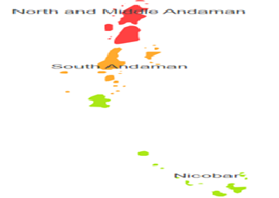

**Agro-Eco Region 20 :** Andaman & Nicobar Islands comprises of Nicobar, North & Middle Andaman and South Andaman districts under Agro Ecological Sub Region (AESR) 20.1 of Agro Ecological Region (AER) 20.The region is hot perhumid ESR with shallow to medium deep, loamy to clayey Red and Yellow and Red Loamy soils, low to medium AWC and LGP 300 days.